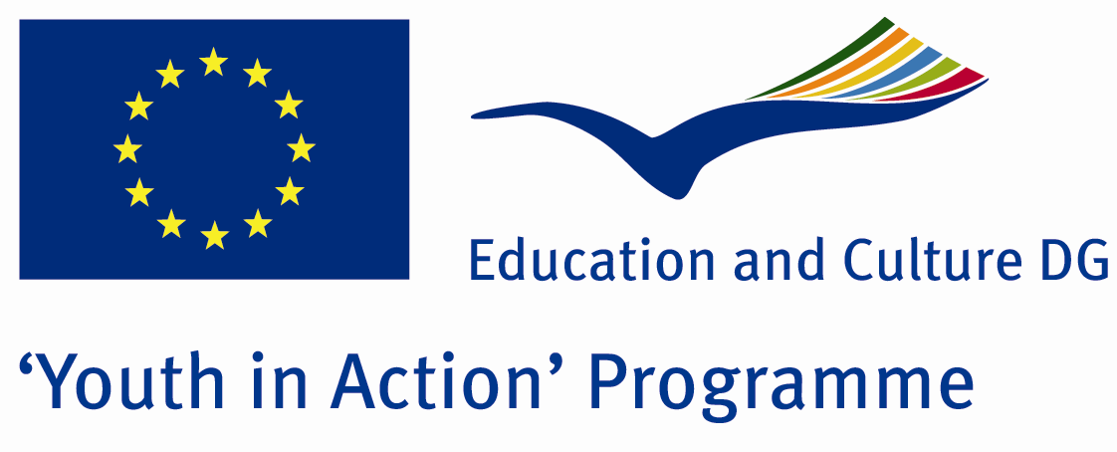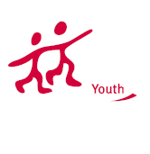

The Sense of Animals and Plants

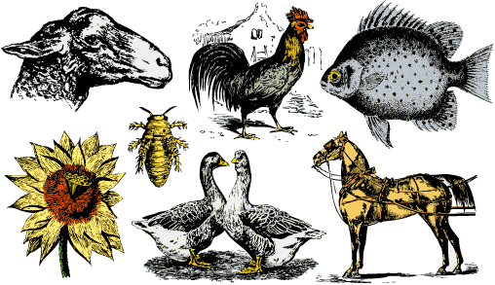

ACTION 1.1 – Youth Exchange

29th October -05th november, 2011

Yalova, TURKEY

Please contact directly to;
adventurerpeacepigeons@gmail.com

Project Summary;

Number of kinds of plants and animals are decreasing day by day. How many people are aware of this fact? What are possible reasons of that? What can we do to prevent these lose? How can we make people conscious and prevent this problem? Answers to such questions will be found in this project.

If you want to join this project, please contact us..

Project Title; The Sense of Animals and Plants

Date and Venue ;
29th October -05th november, 2011

Yalova, TURKEY

Target Group ; Municipalities, City Councils and Non-Governmental organizations,
youth groups,culture and art groups,e.t.c

Participants ; 5 people from each country (over 18 -25 ). Totally 8 countries.

Conditions ; Accommodation, board and programme costs will be financed through European Commission Youth in Action Programme . Travel costs will be reimbursed in 70% (APEX Tarrifs). Organizations from all 27 EU member countries plus Liechtenstein , Norway and Iceland are eligible to take part.

Working language: English

Organizer; Adventurer Peace Pigeons

How to apply: If you are interested, please send your Part III forms to
e-mail . (in word file). Scan Part3 format is enough for application. (Fulfilled Part III which you can find in the attachment, of course signed and stamped) ..

Next step 2;
Original send via regular post to this address please:

Ertan DERİN
Fevzi Çakmak Mahallesi Tuncer Sokak No:6 PENDİK/İSTANBUL/TÜRKİYE
e-mail : adventurerpeacepigeons@gmail.com
Mobile : 0090 542 393 93 90

If you have any questions you may contact with: adventurerpeacepigeons@gmail.com

Deadline for application; until 15 May 2011.

For Further information:
Contact Person
Ertan DERİN
Fevzi Çakmak Mahallesi Tuncer Sokak No:6 PENDİK/İSTANBUL/TÜRKİYE
e-mail : adventurerpeacepigeons@gmail.com
Mobile : 0090 542 393 93 90

